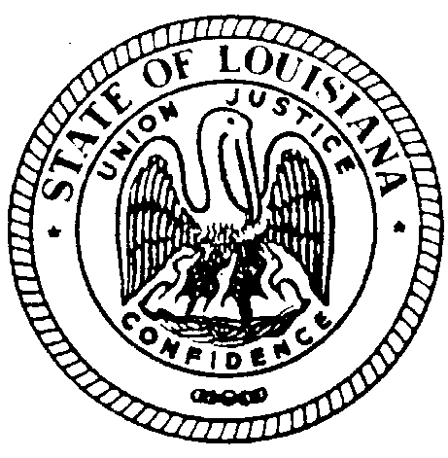

State of Louisiana
The Louisiana State Board for Hearing Aid Dealers
308 Gregory Dr. Luling, Louisiana 70070 Voice/Text: (504) 655-0383 E-mail– labhad@la.gov

PRACTICAL EXAMINATION NOTICE:
§2446. Examination by written and practical tests
An applicant for a license who is notified by the board that he has fulfilled the requirements of
R.S. 37:2445 shall appear at a time, place and before such persons as the Board may
designate, to be examined by written and practical tests in order to demonstrate that he is
qualified to engage in the fitting and selling of hearing aids.
The board shall give at least one examination of the type prescribed in this section each year,
and such additional examinations as the volume of applications may make appropriate.
Acts 1968, No. 302, §6, eff. Jan. 1, 1969.

DATE: SATURDAY JUNE 9, 2018
TIME: 1:00PM
LOCATION: EMBASSY SUITES
4914 CONSTITUTION AVENUE
BATON ROUGE, LA 70808

All qualified applicants will be informed what materials to bring for the examination.

Submitted on behalf of The Louisiana State Board for Hearing Aid Dealers by:

-Dina Zeevi
Administrative Secretary

BOARD MEMBERS
District I: Bryan Stinson/Emily Goerges District II: Jerri Jenelle Sharp District III: Cherry Collum
District IV: Kirt Loupe District V: Jeremy Stroud District VI: Mary Christy
State Health Officer: Jimmy Guidry
Elderly Consumer: Awaiting Governor Appointment

